**Project Design Phase-II**

**Technology Stack(Architecture & Stack)**

|  |  |
| --- | --- |
| Date | 25 October 2022 |
| Team ID | PNT2022TMID24781 |
| Project Name | Smart solution for Railways |

**Technical Architecture:**

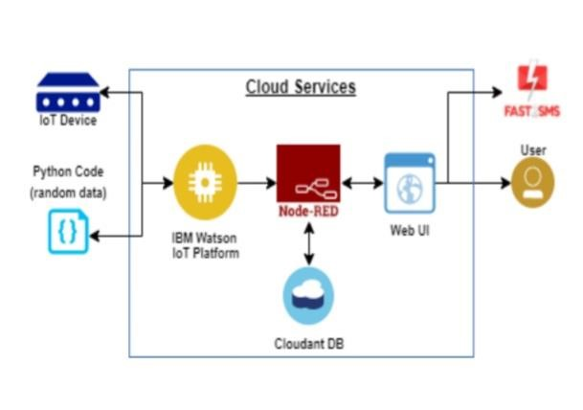

**Table-1: Components & Technologies:**

|  |  |  |  |
| --- | --- | --- | --- |
| **S.No** | **Component** | **Description** | **Technology** |
| 1. | UserInterface | How user interacts with application e.g. WebUI,Mobile App,Chatbotetc. | HTML, CSS, JavaScript, React Js, Flutter |
| 2. | Application Logic-1 | Logic for a process in the application | MIT app inventor, |
| 3. | Application Logic-2 | Logic for a process in the application | IBM Watson STT service |
| 4. | Application Logic-3 | Logic for a process in the application | IBM Watson Assistant |
| 5. | Database | Data Type, Configurations etc. | MySQL |
| 6. | Cloud Database | Database Service on Cloud | IBMDB2, Firebase |
| 7. | File Storage | File storage requirements | IBM Block Storage |
| 8. | External API-1 | Purpose of External API used in the application | Stripe Payment API |
| 9. | Machine Learning Model | Purpose of Machine Learning Model | Recommendation system |
| 10. | Infrastructure(Server/Cloud) | Application Deployment on Cloud system | Kubernetes, Heroku |

**Table-2: Application Characteristics:**

|  |  |  |  |
| --- | --- | --- | --- |
| **S.No** | **Characteristics** | **Description** | **Technology** |
| 1. | Open-Source Frameworks | List the open-source frameworks used | React JS, Flutter |
| 2. | Security Implementations | List all the security/access controls implemented,use of firewalls etc. | SHA-256, Encryptions, IAM Controls,OWASP |
| 3. | Scalable Architecture | Justify the scalability of architecture (3 – tier, Microservices) | 3–Tier architecture |
| 4. | Availability | Justify the availability of application (e.g.use of load balancers,distributed servers etc.) | Nginx Load balancers, Fault tolerantsystems |
| 5. | Performance | Design consideration for the performance of the application(number of requests per sec,use of Cache,useofCDN’s)etc. | Multicore processors forvservers |